Mongo db lab exercise:
1. Practice CRUD operations on Mongo
Question 1: Create two collections -- emp and dept.
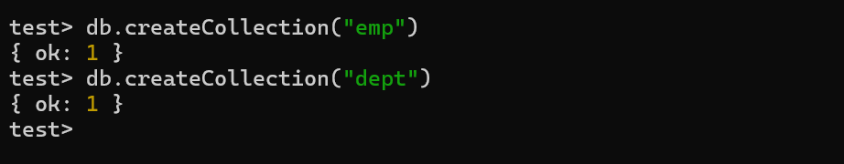

Question 2: Insert the emp and dept records.
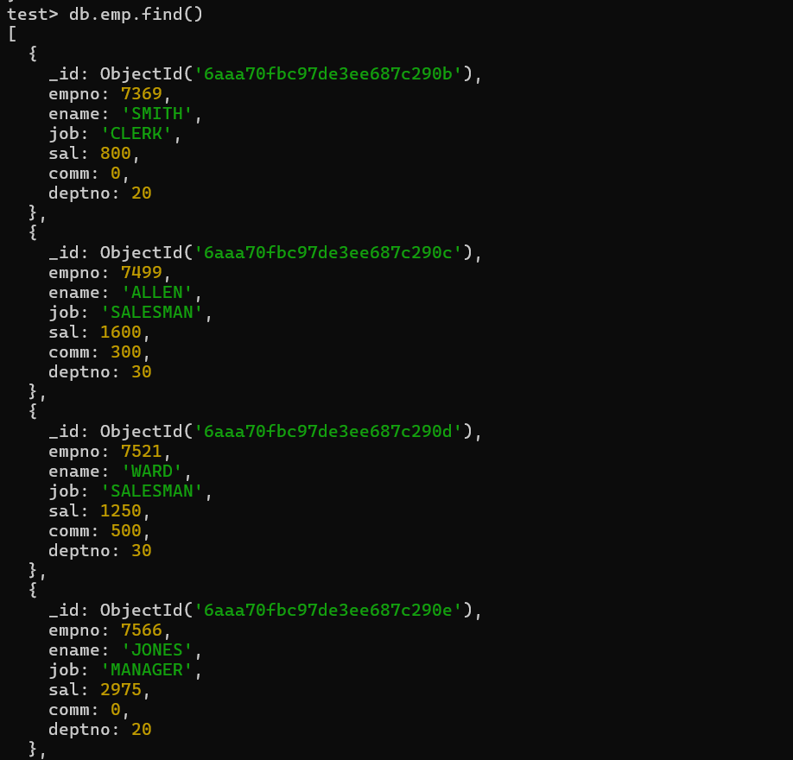

Question 3: Increase salary of dept 10 emps by 100
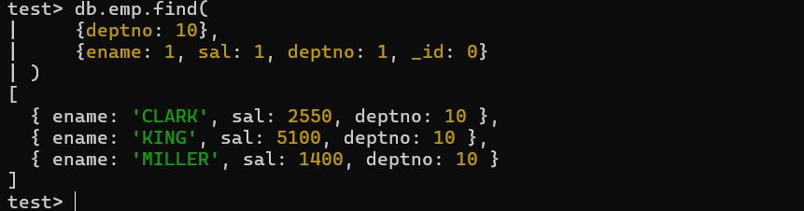
Question 4: Display emp name, job, deptno, sal in sorted order of deptno, job, sal (desc) for all emps whose sal more than 1000
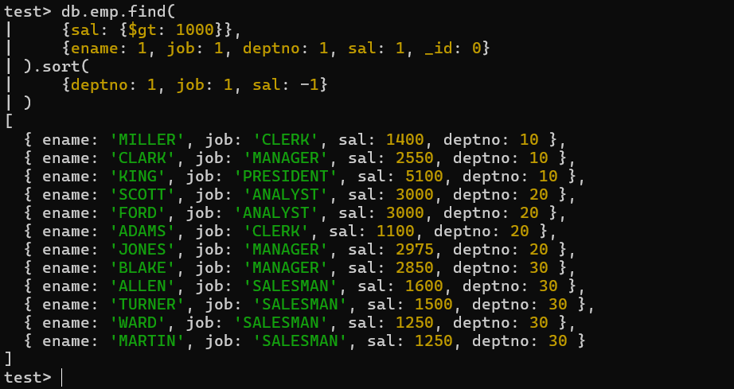

Question 5:
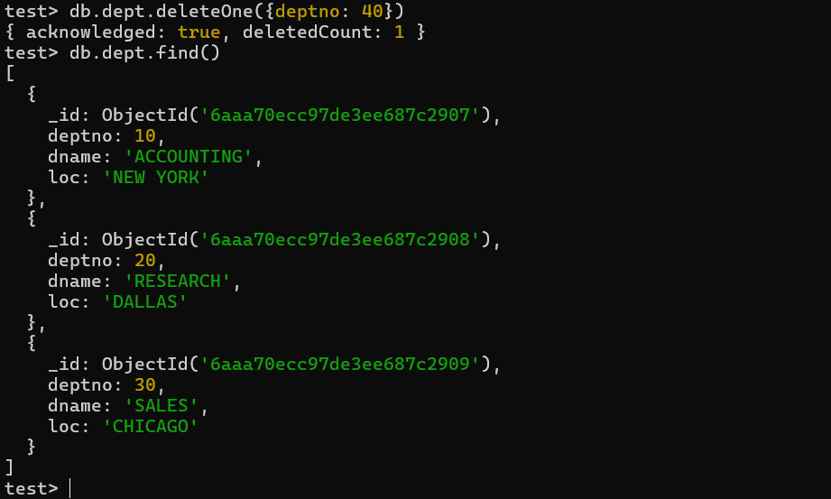

2. Learn grouping operations using Mongo aggregation pipeline
Question 1: Display job wise total sal, max sal, min sal, and avg sal for all jobs other than PRESIDENT
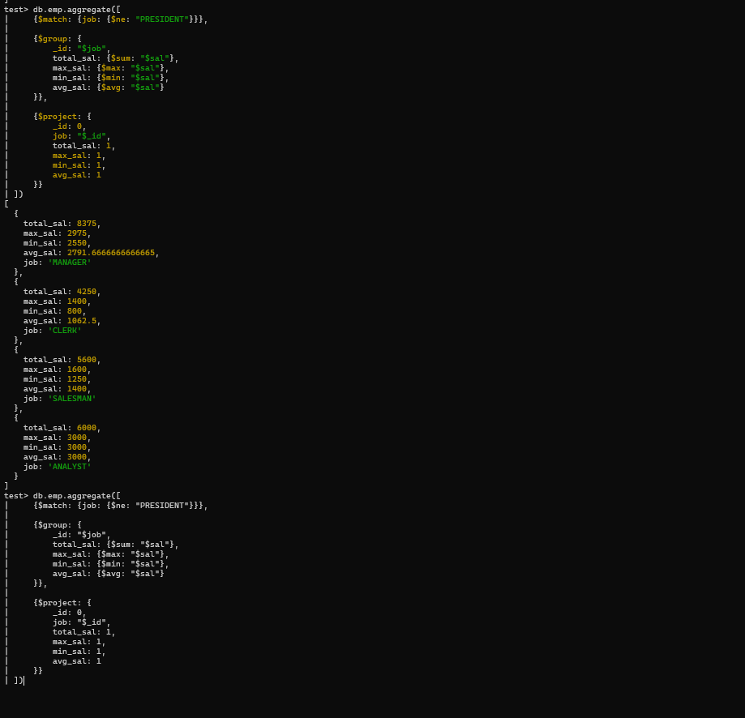

Question 2: Display emp name, dept name, income (sal + comm) in sorted order of their income
